Creation of database

DB it will take 5 minutes to complete

Read replica takes 30 minutes to complete

RDS is a server less service.

Note: For this SG should have MySQL port 3306

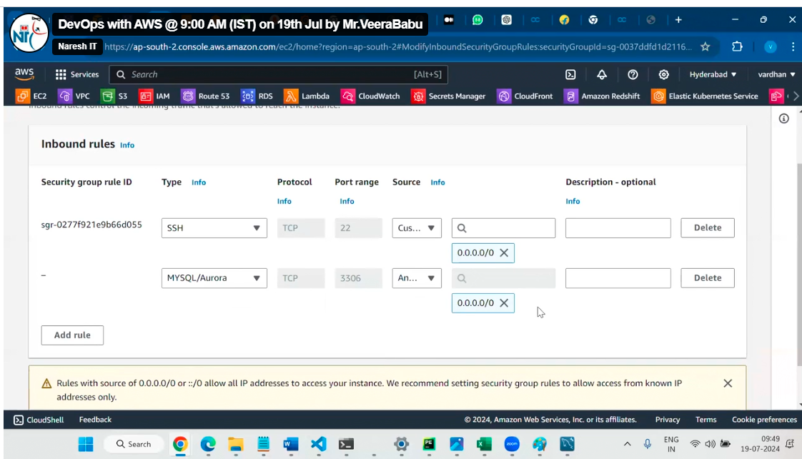

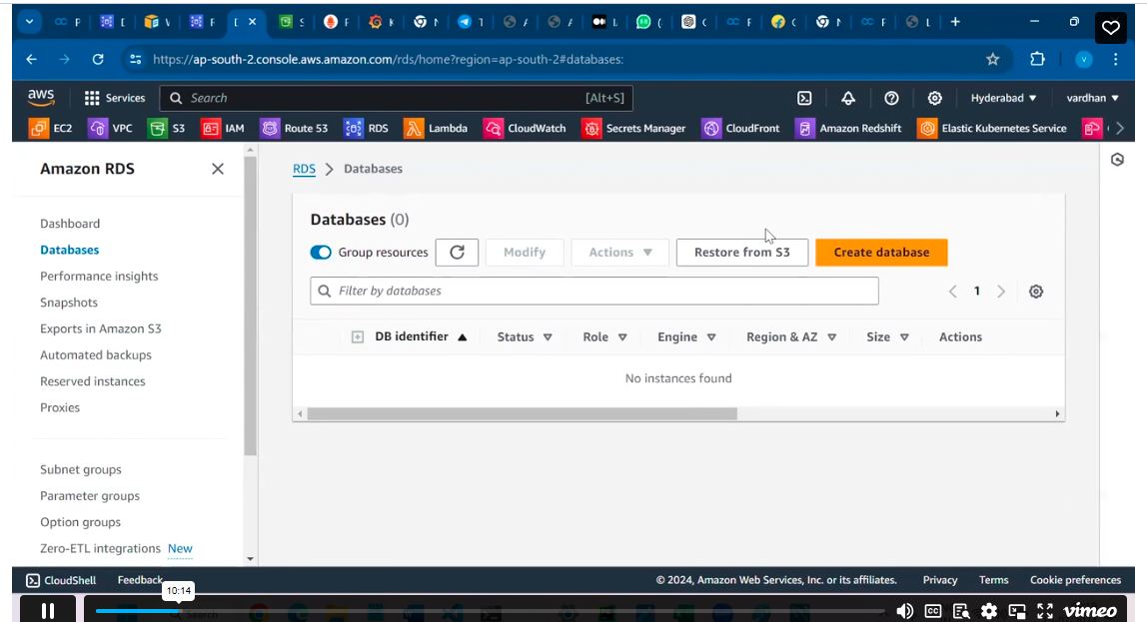

click on create database.

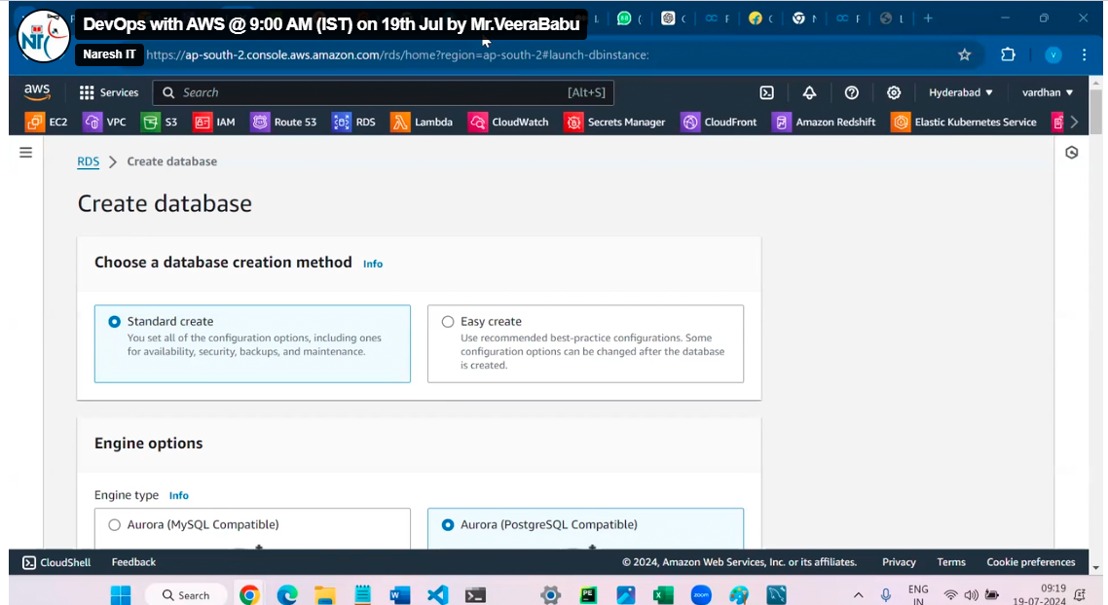

Select MySQL

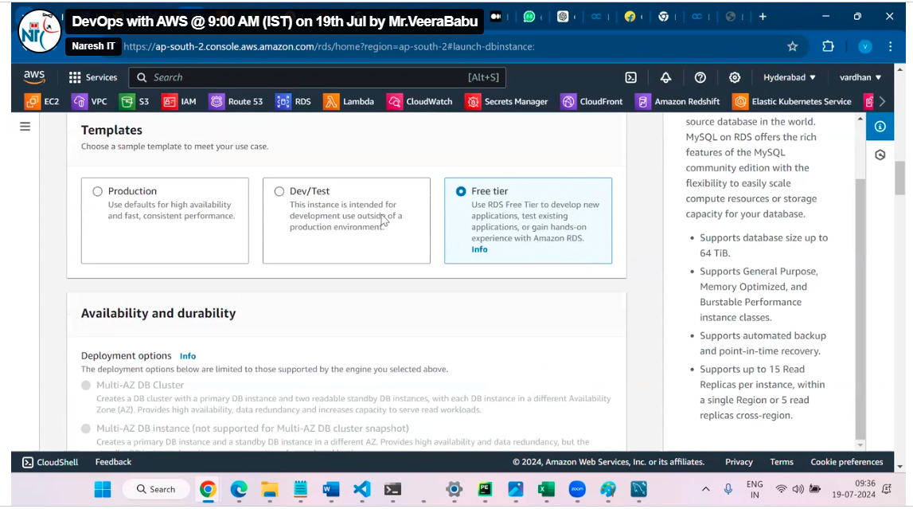

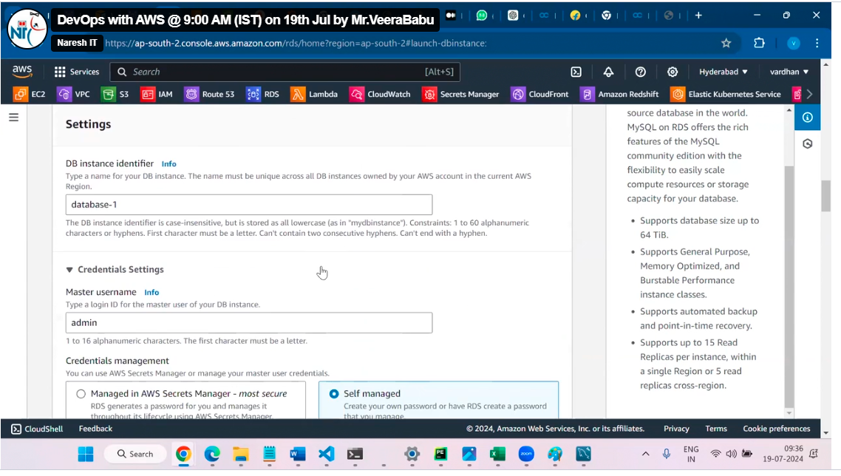

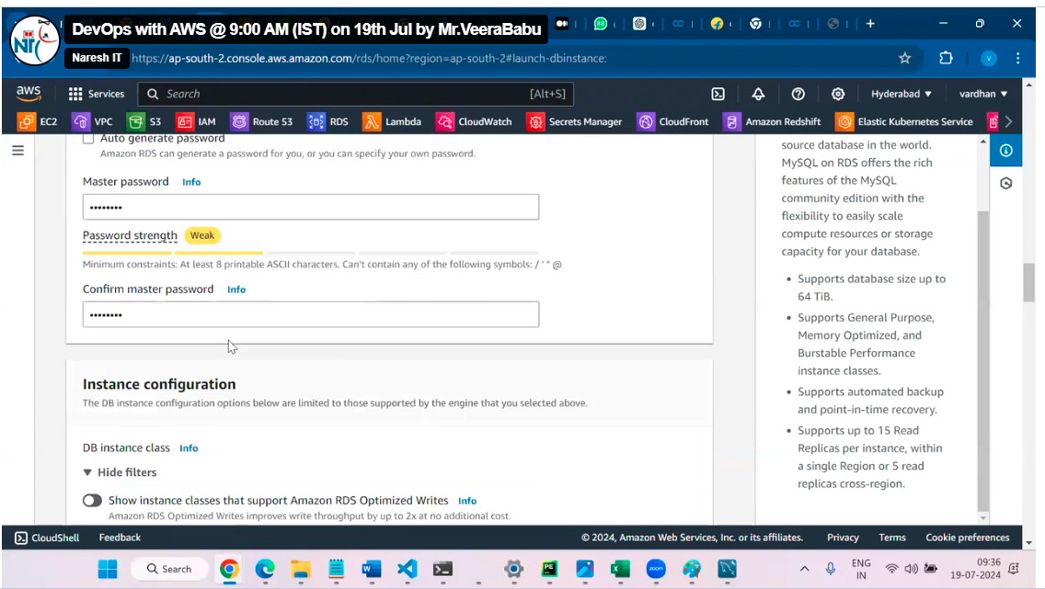

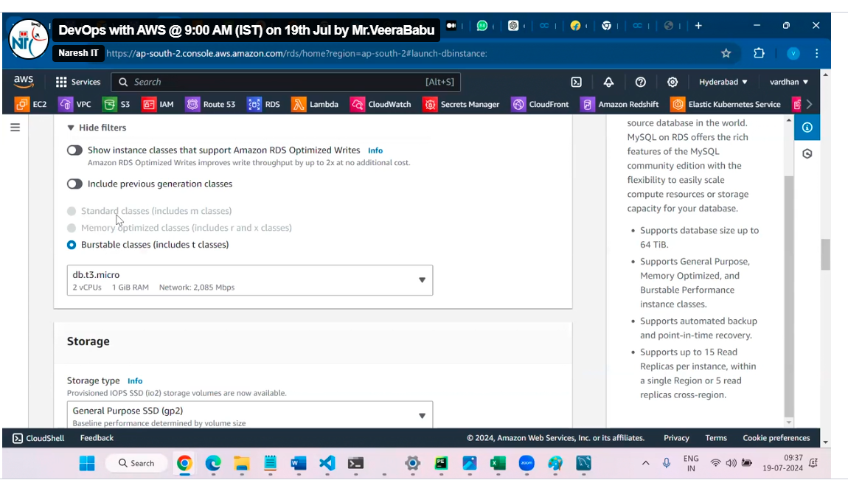

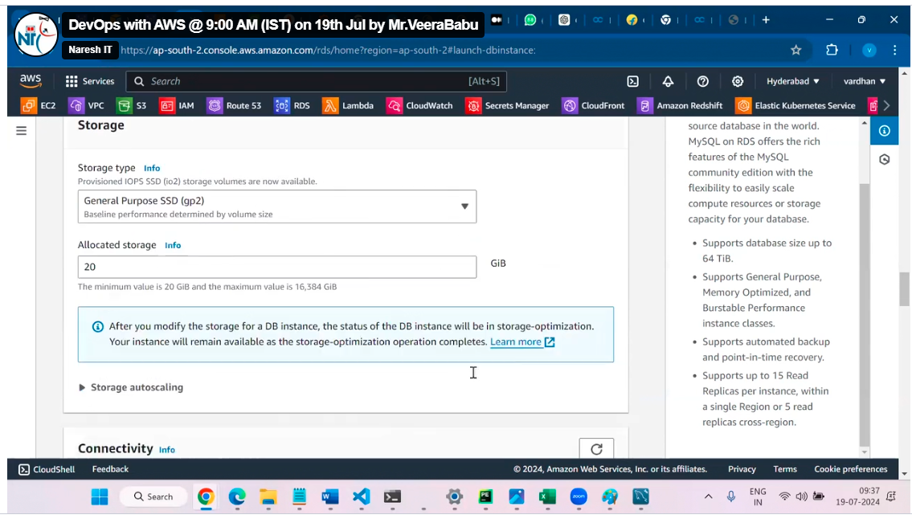

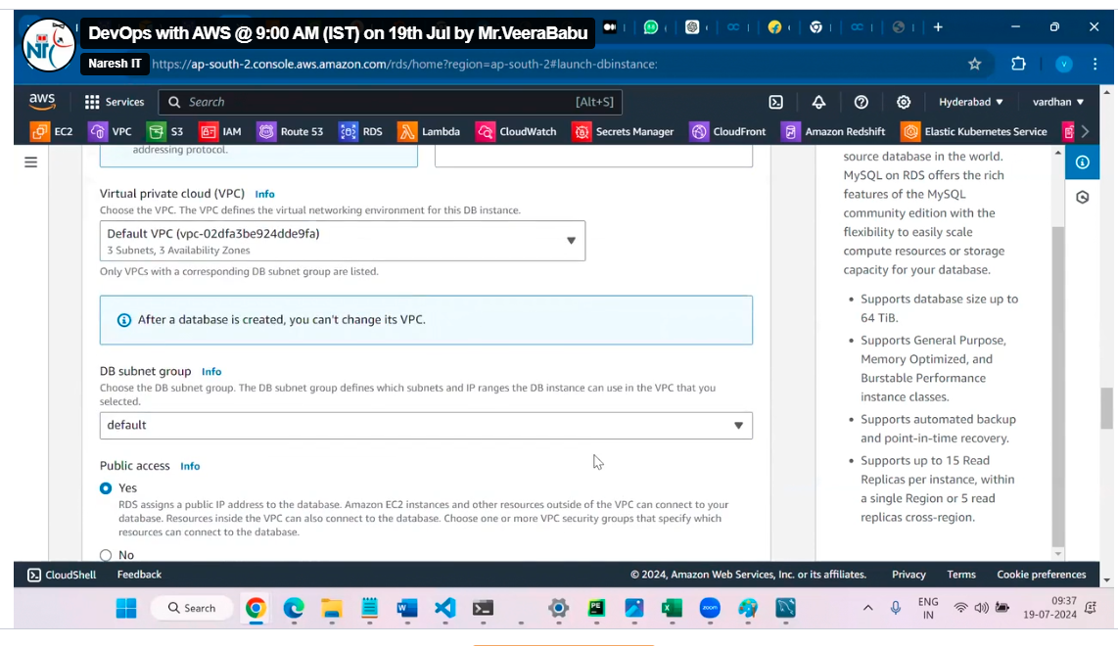

Public access is not in real time.

Click on create database.

To connect RDS from external we have third party tools like

MYSQL workbench

PG admin

How to install MYSQL workbench

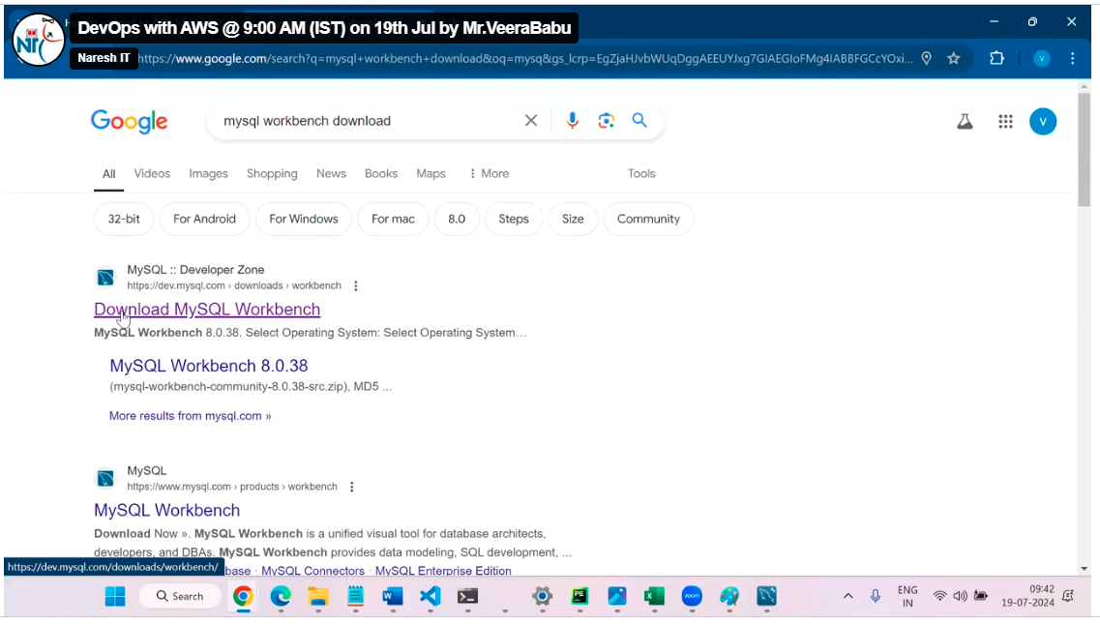

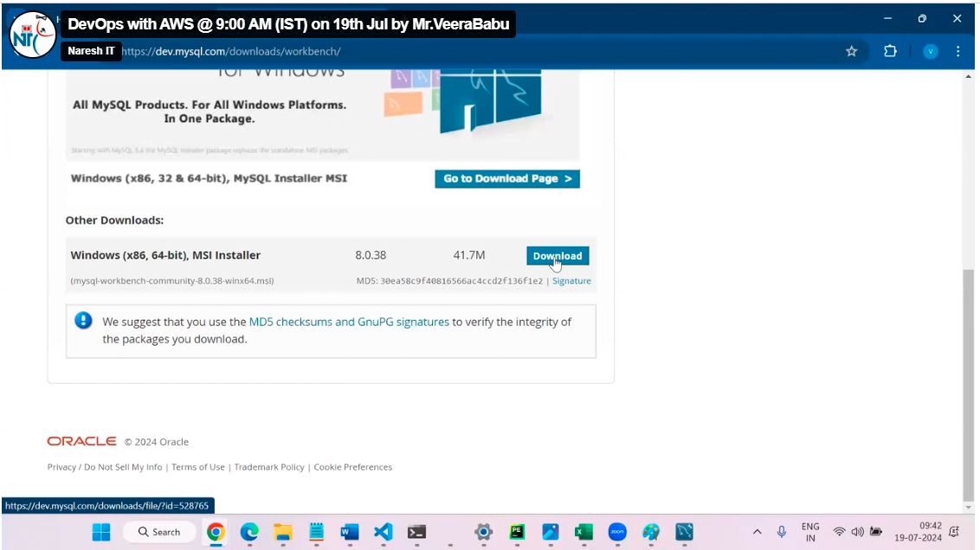

Then click on bottom no thanks just download no need to sign in.

You can install from above then

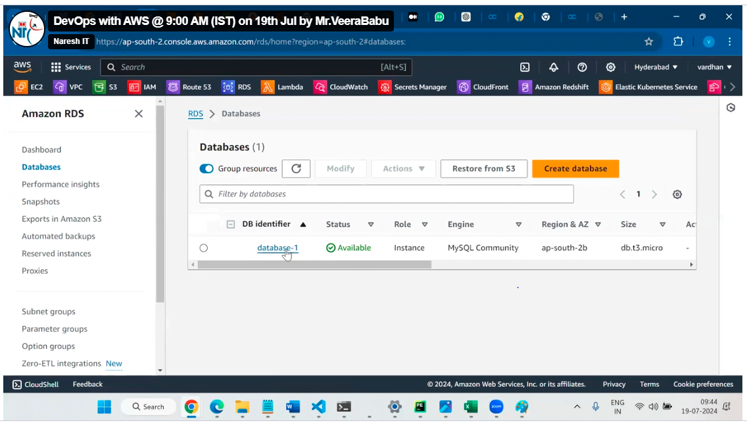

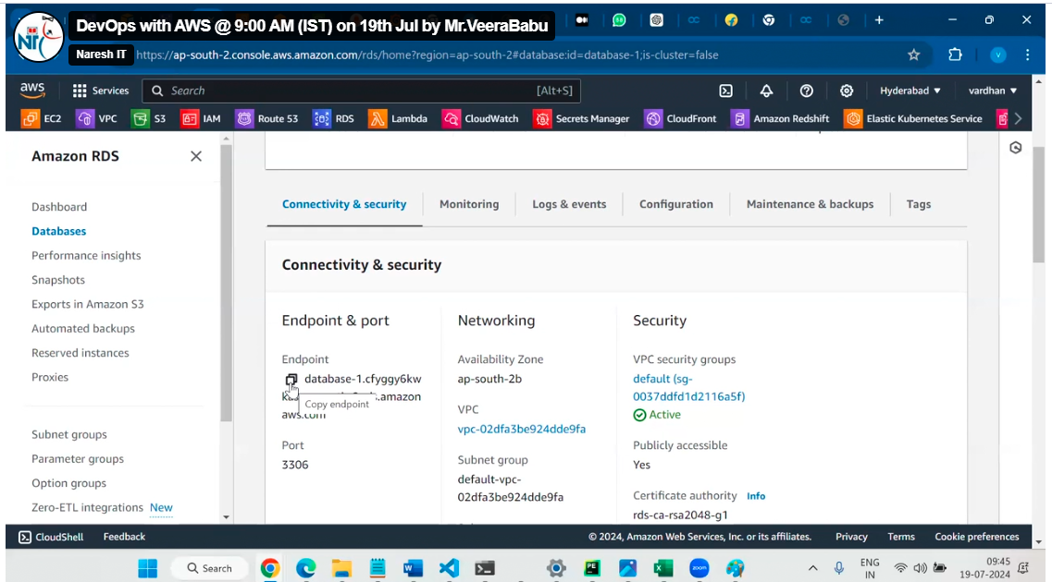

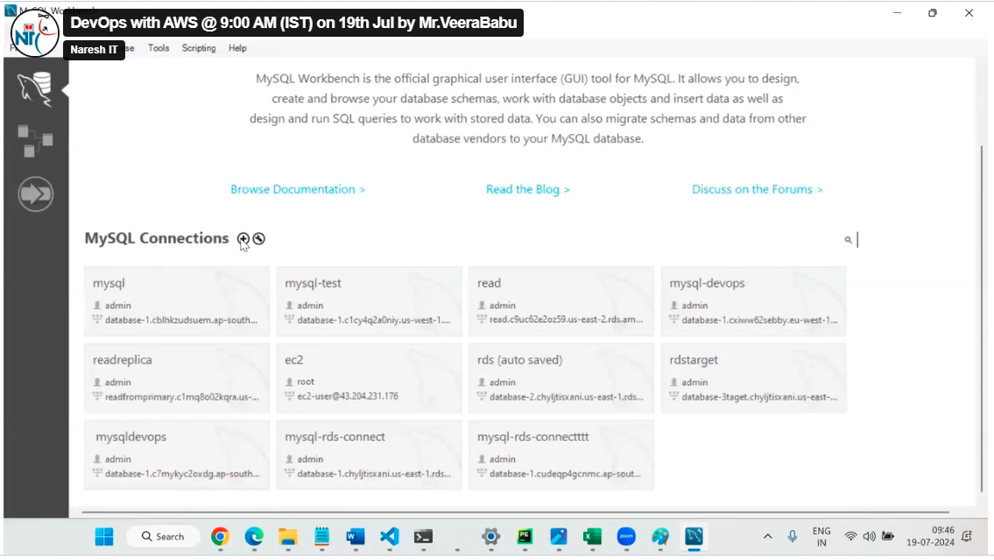

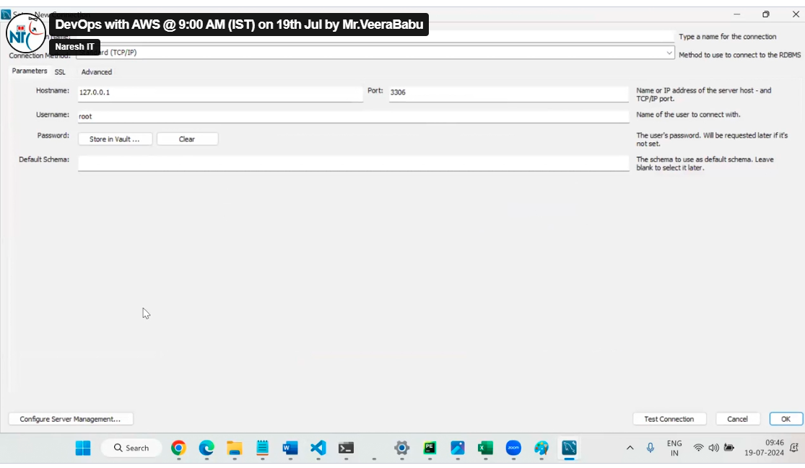

Name any name

End point take from RDS end point and give password given while creating RDS

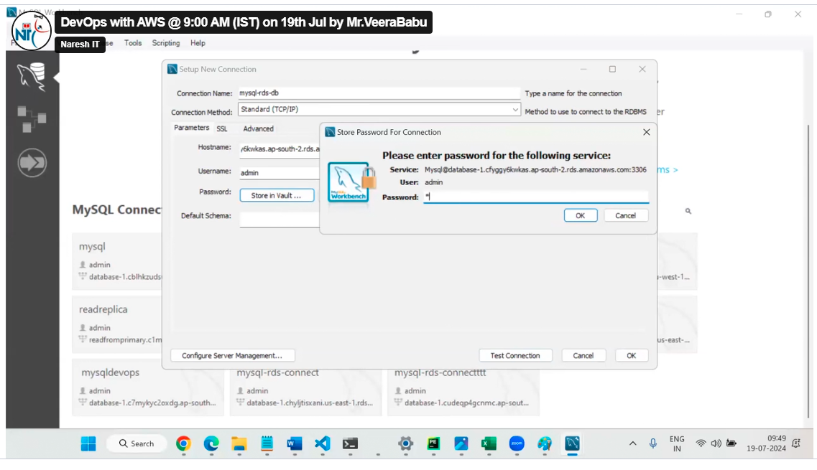

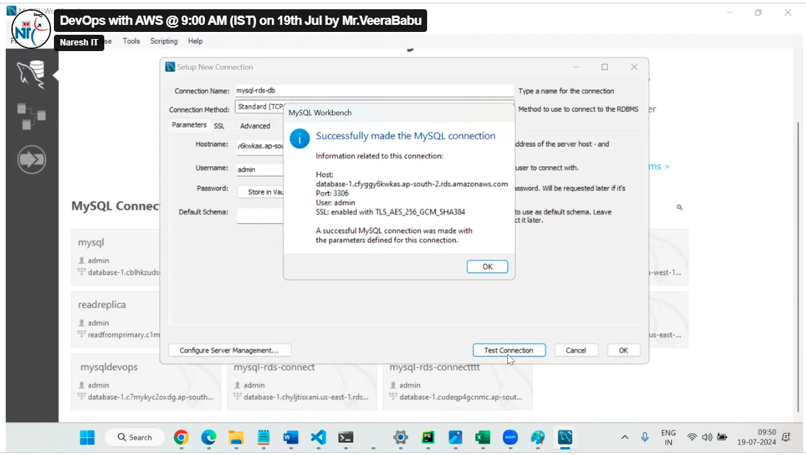

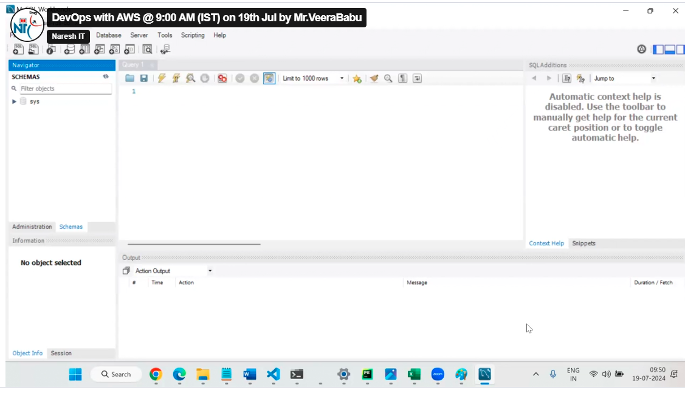

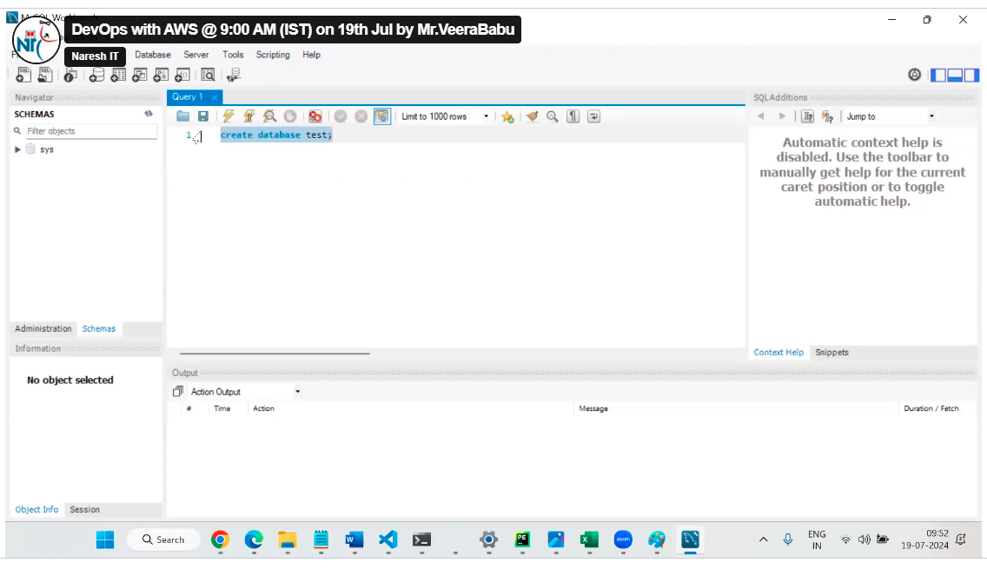

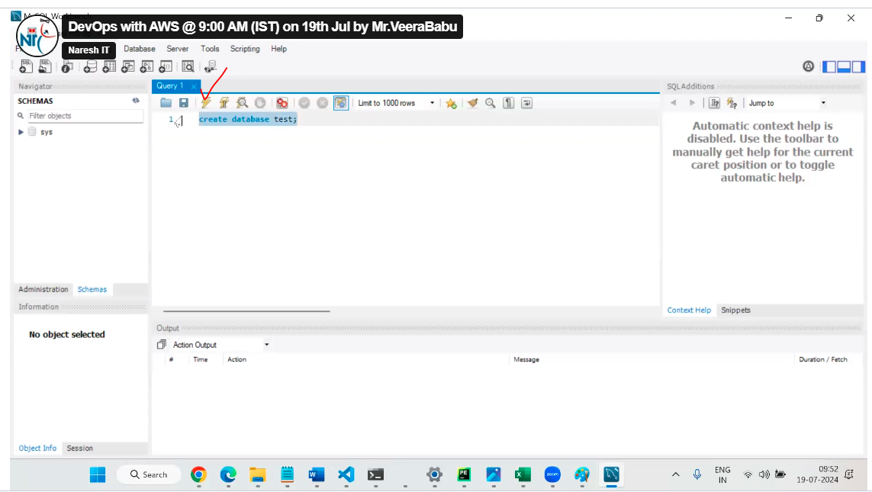

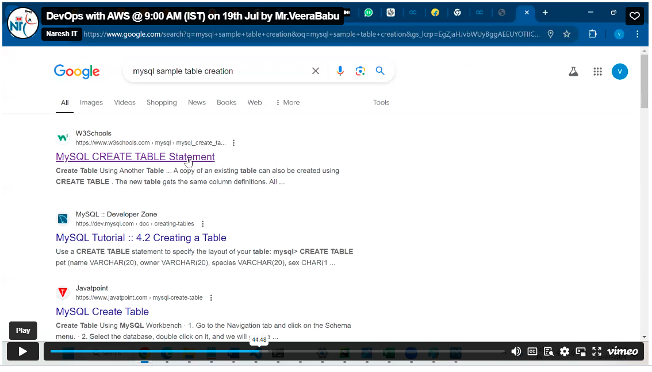

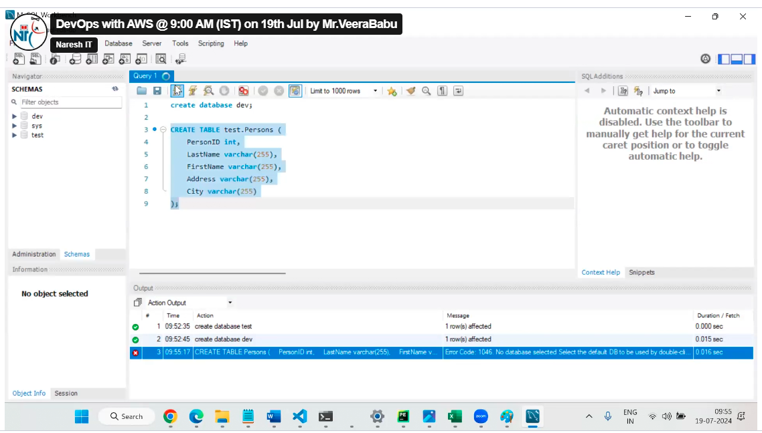

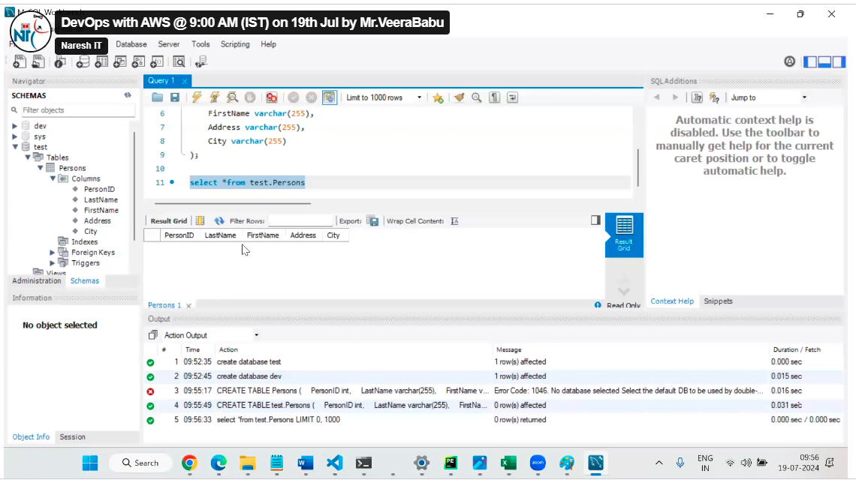

In above case we are enable public subnet access to RDS in this case only we can connect from external my SQL work bench

But in real time RDS is create in private subnet

The command to connect database from application server as below but my SQL package should be installed in application server

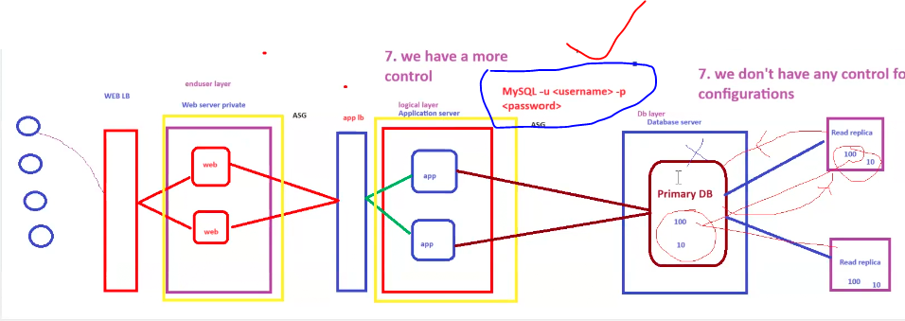

Follow the below document from veera sir

# RDS : Amazon Relational Database Service

Select create database

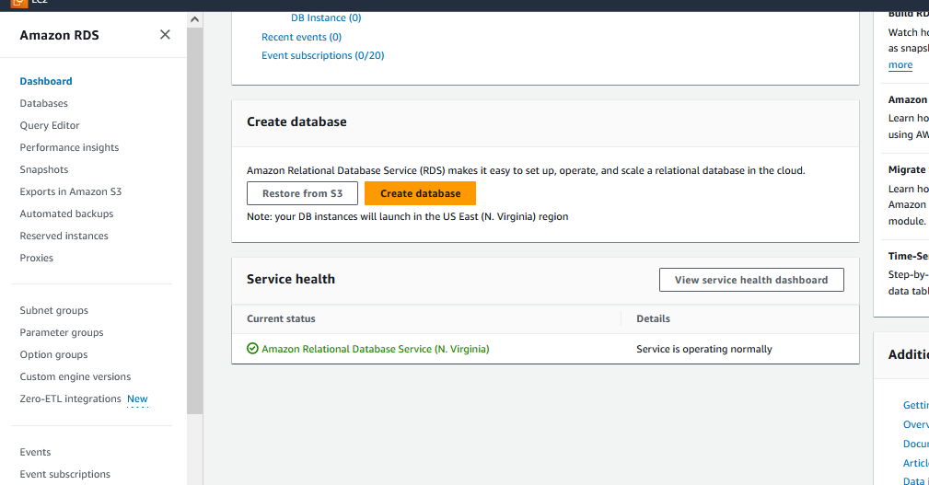

Select standard create and choose MyQL

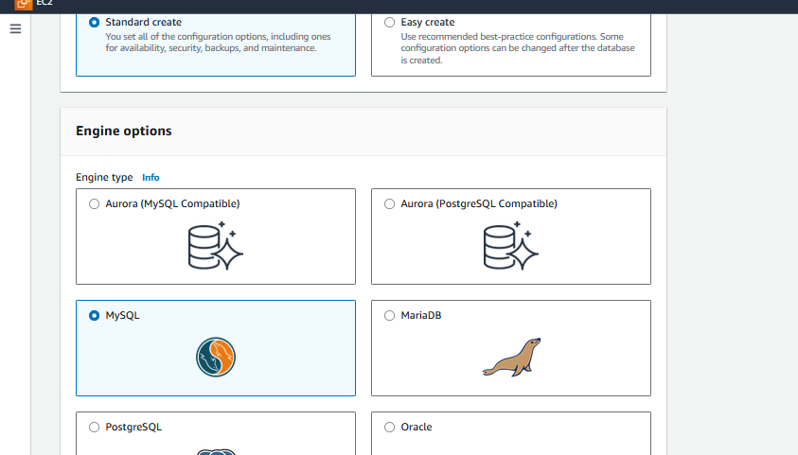

Choose free tier model

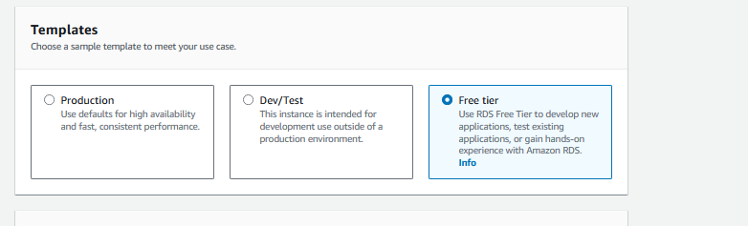

Provide password

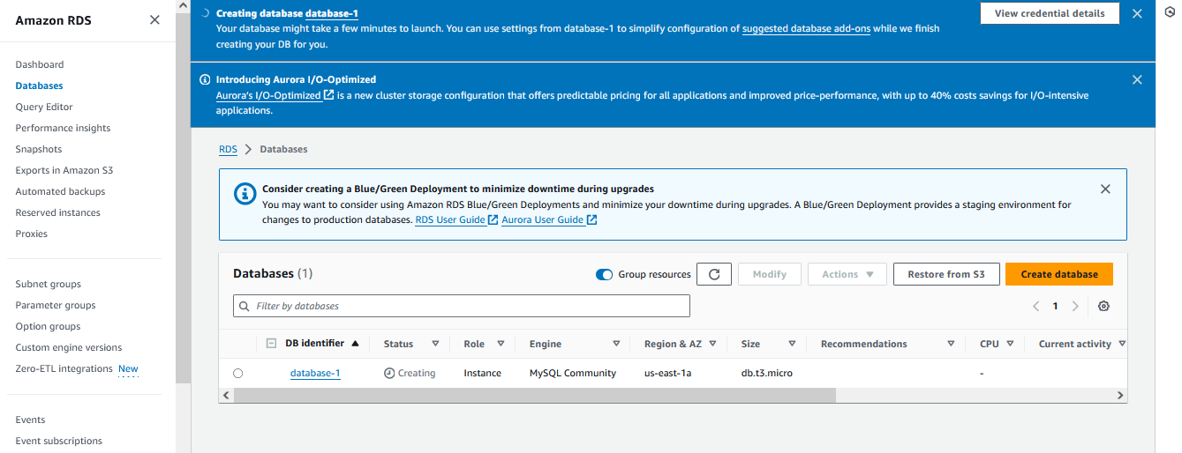

if you want to see your credentials, you can click on view credentials details



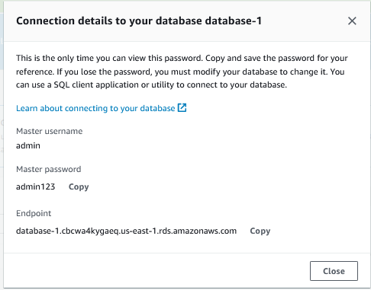

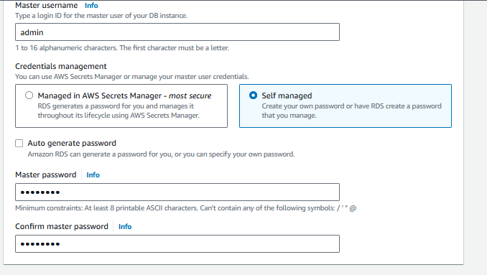

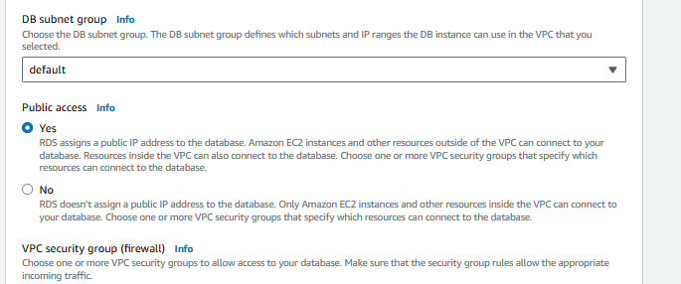

Click on create database button

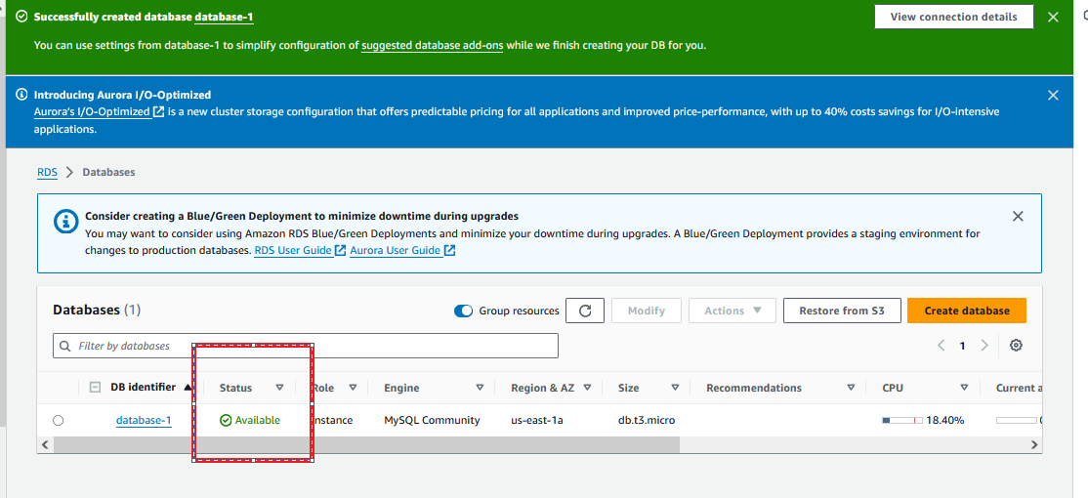

Database would take few mins to up and running.

Click on the Database-1 to capture the endpoint.

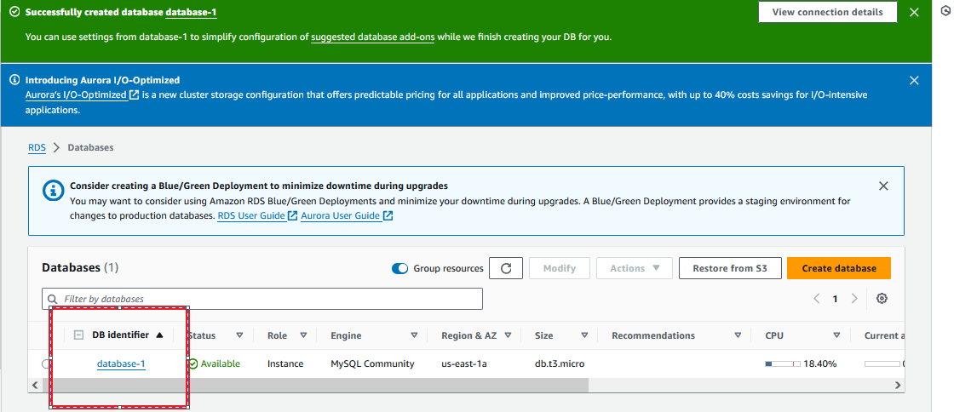

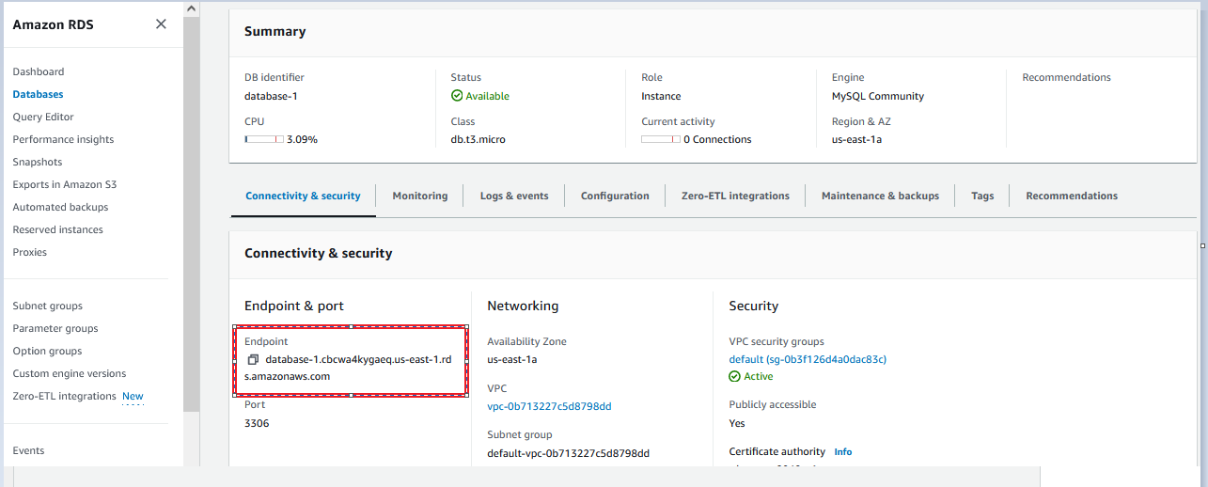

Copy the Endpoint

Endpoint: database-1.cbcwa4kygaeq.us-east-1.rds.amazonaws.com

This endpoint we are using it to connect from MySQL client.

# [MySQL :: MySQL Workbench](https://www.mysql.com/products/workbench/) download

<https://www.mysql.com/products/workbench/>

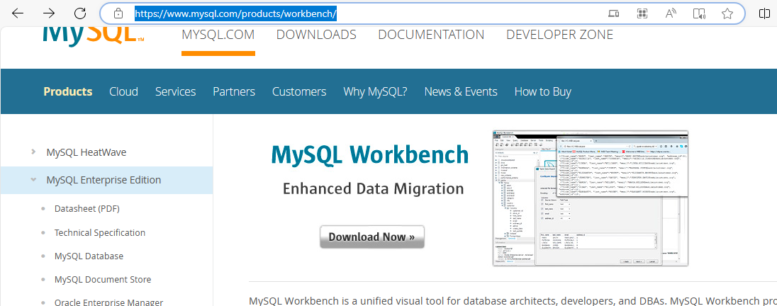

Click on Download Now

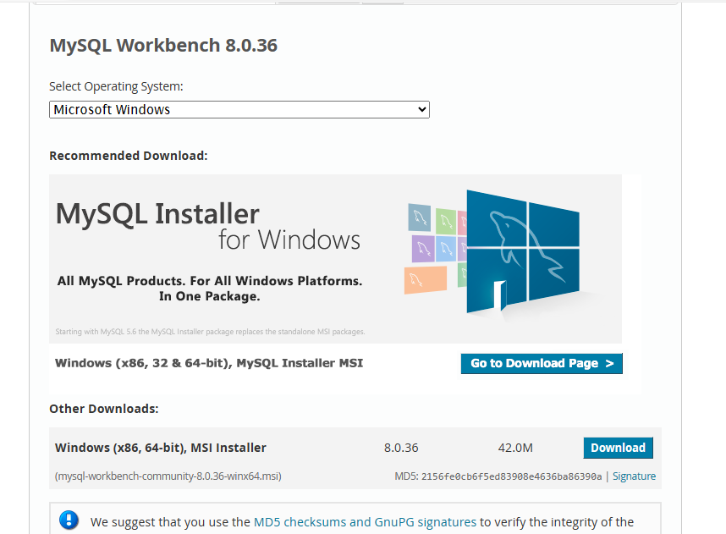

Click on Download button

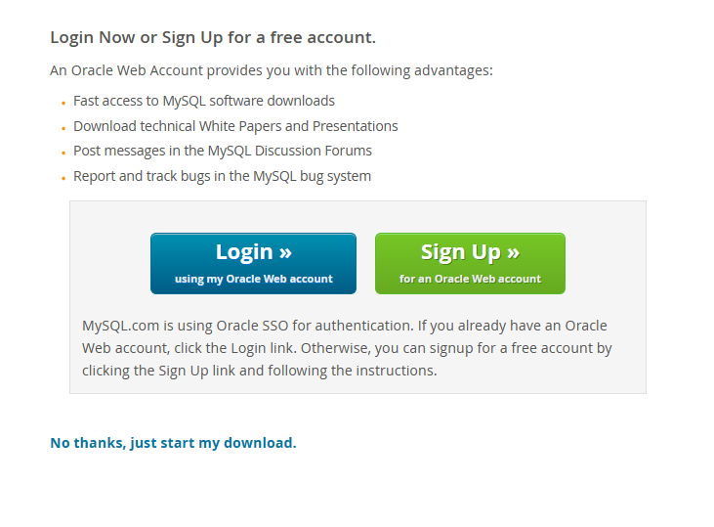

**Click here to download with login :** [**No thanks, just start my download.**](https://dev.mysql.com/get/Downloads/MySQLGUITools/mysql-workbench-community-8.0.36-winx64.msi)

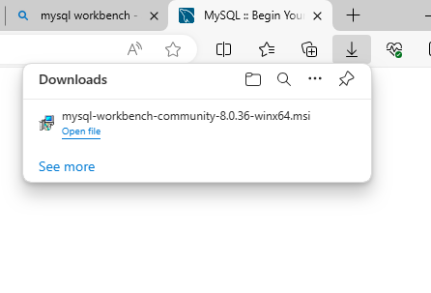

The download mysql client will be available in downloads, then double click on .msi file

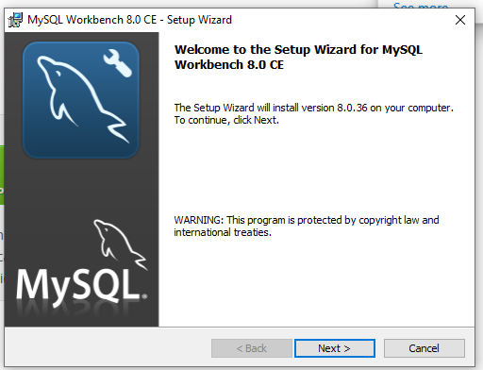

Click on Next

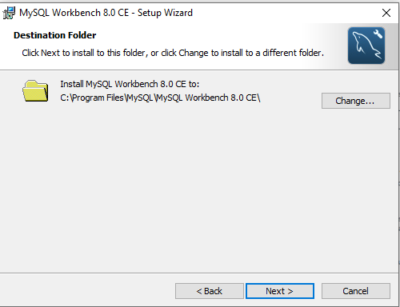

Click on Next

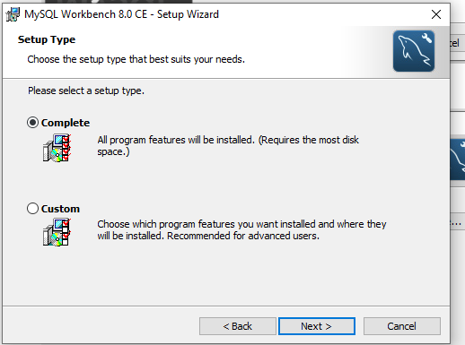

Click on Next

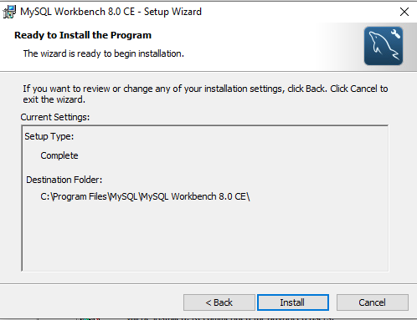

Click on Install

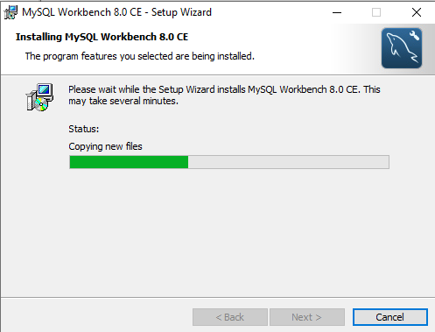

Wait till Finish button shows

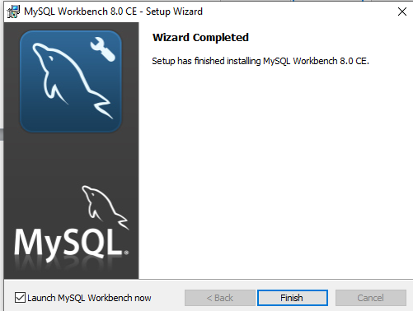

Click on Finish

# Now launch the mysql workbench to connect AWS RDS

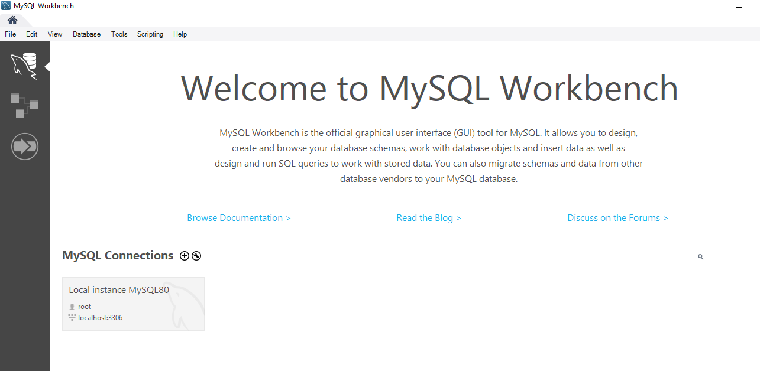

Click on MySQL connections + symbol to configure our RDS mysql db

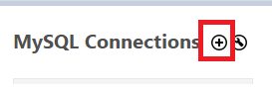

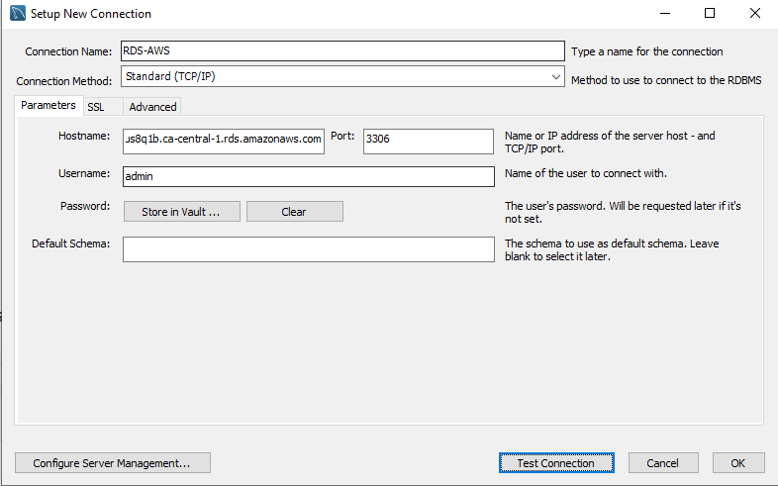

Click on the Store in Vault to enter the password

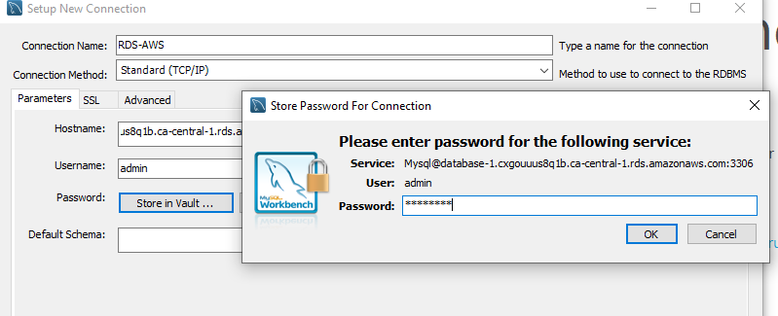

Click on OK and then click on Test connection.

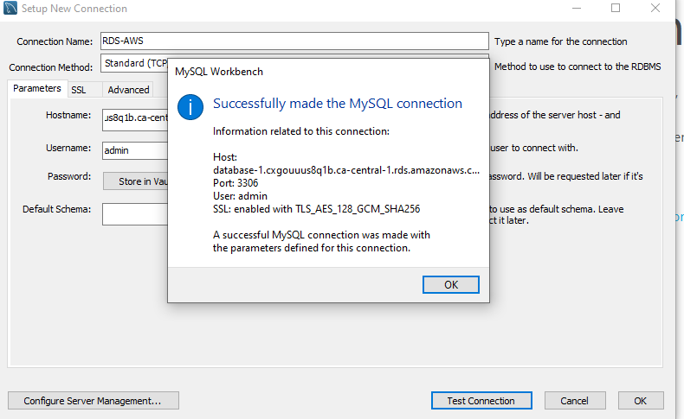

Connection got successful

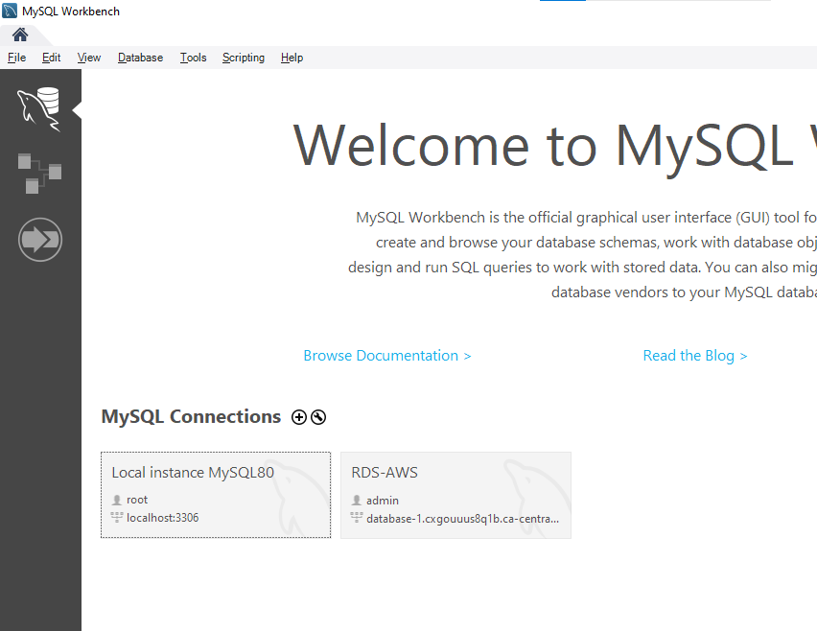

Click on our RDS-AWS db to create database and tables.

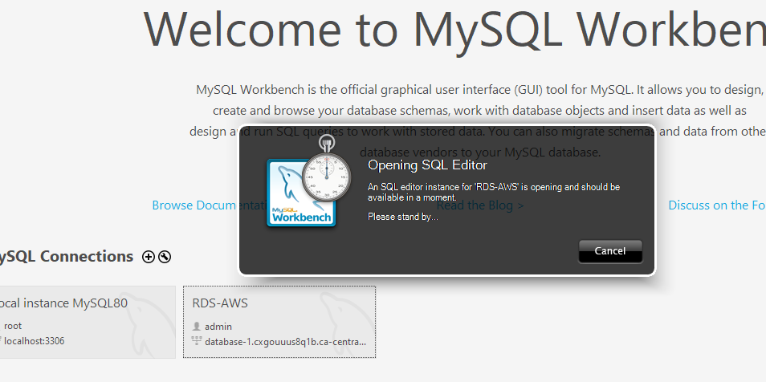

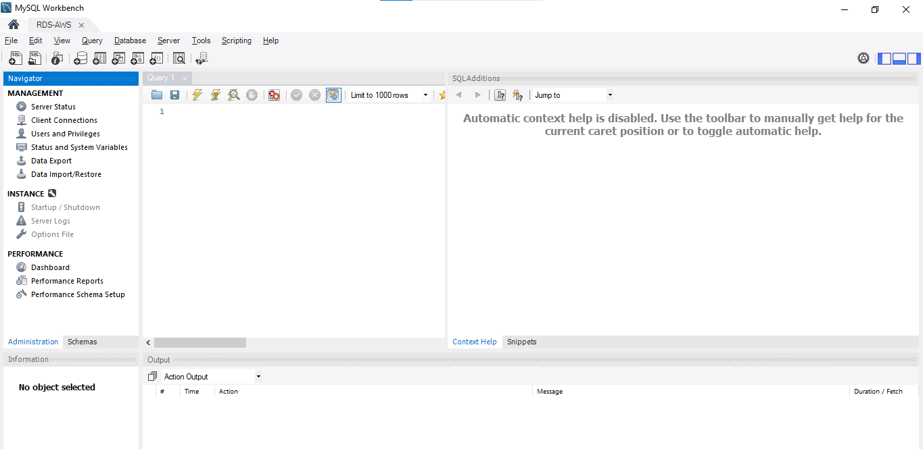

Click on Schemas to see the databases.

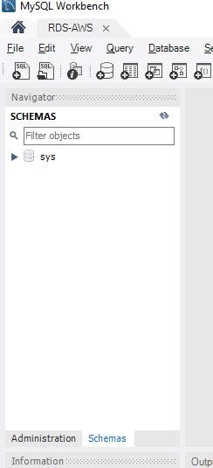

# Create Database, Table and rows

Click on the execute query button

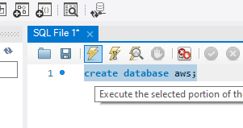

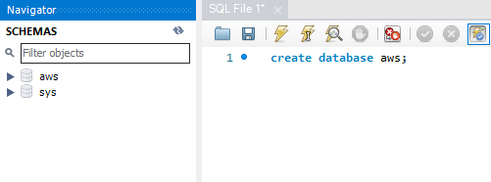

Aws db created

Run the below query to create a table in aws db

|  |
| --- |
| create table aws.employee (empid int auto_increment primary key,  first_name varchar(30),  last_name varchar(30),  email varchar(50),  department varchar(40),  salary decimal(10,2),  hire_date date  ); |

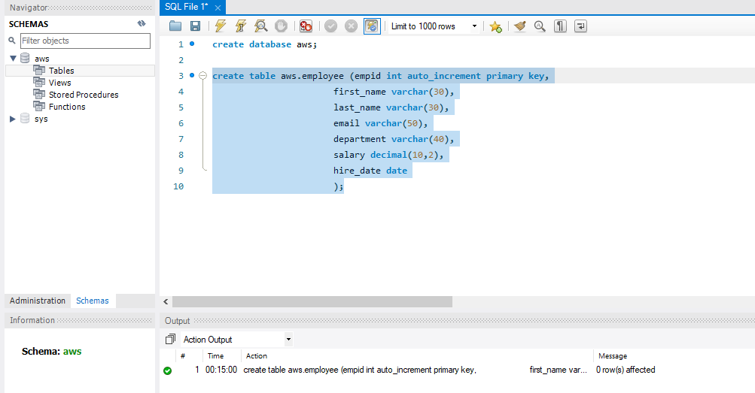

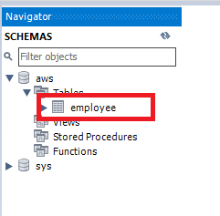

Employee table created

Run the below 2 query to insert the data and

|  |
| --- |
| insert into aws.employee (first_name, last_name, email, department, salary, hire_date)  values ('David', 'John','david@12345.com','Engineer',50000.00,'2024-05-02');  insert into aws.employee (first_name, last_name, email, department, salary, hire_date)  values ('Mark', 'Anthony','mark@45678.com','QA',60000.00,'2023-03-05'); |

Run the below query to view the data

|  |
| --- |
| select * from aws.employee; |

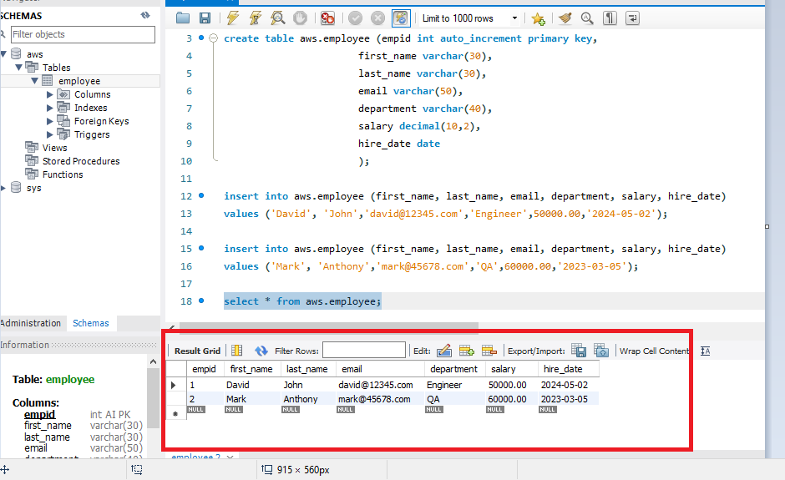

Now we able to see the data in employee table

# Create Read Replica from Master Data Base:

Select database and click on read replica

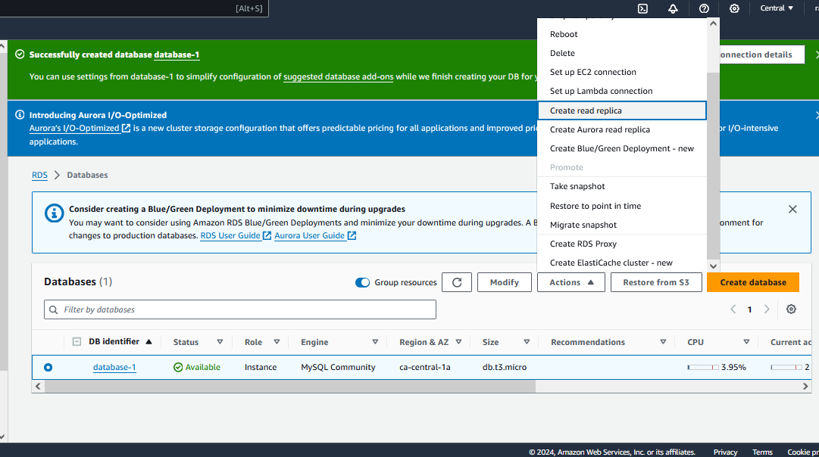

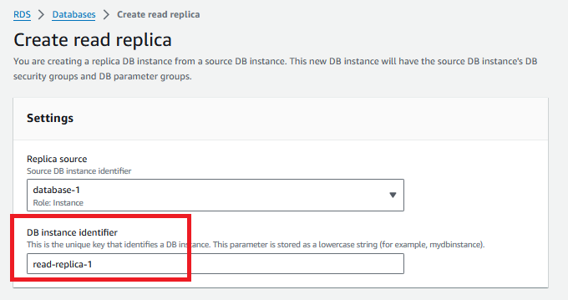

Provide read-replica-1 and the click on create read replica button

In this no need to change any thing except region (select different region for higher availability)

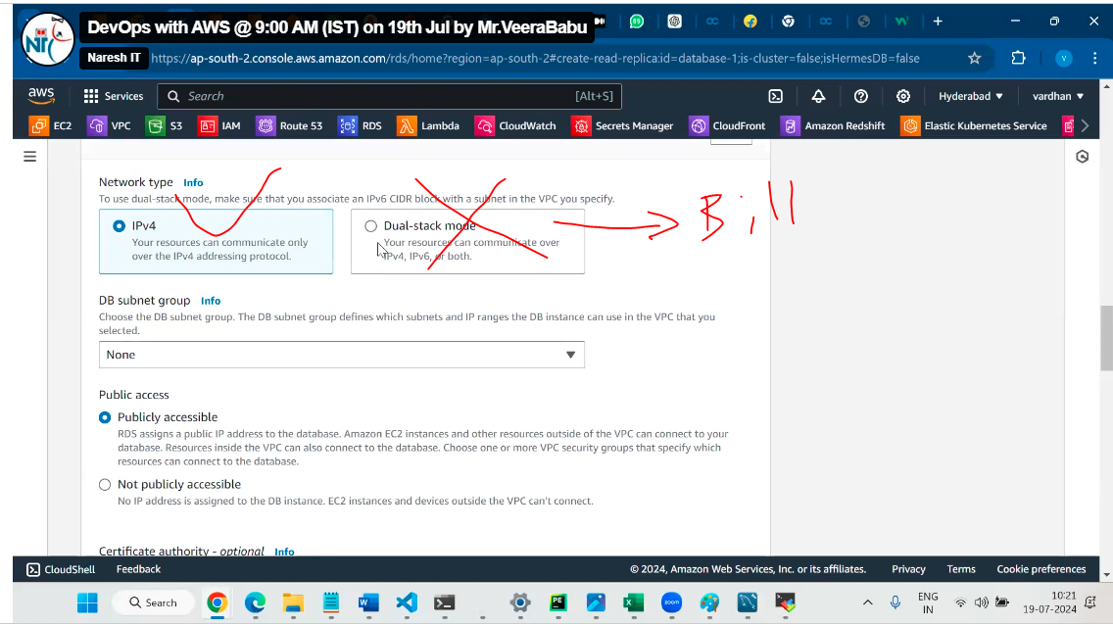

To create read replica it will take 30minutes

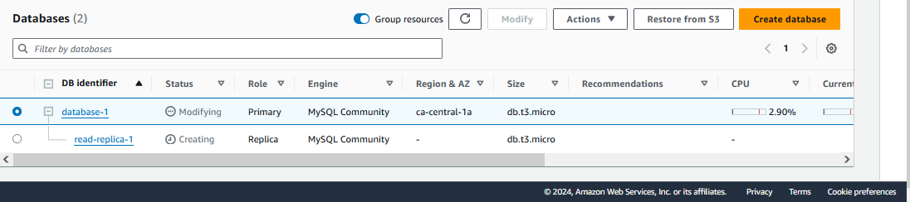

Lets wait for up and running

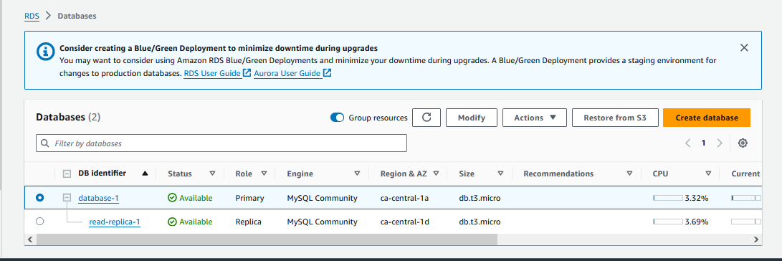

Both replica and Primary db available

Open read-replica-1 to copy the endpoint to connect through mysql client.

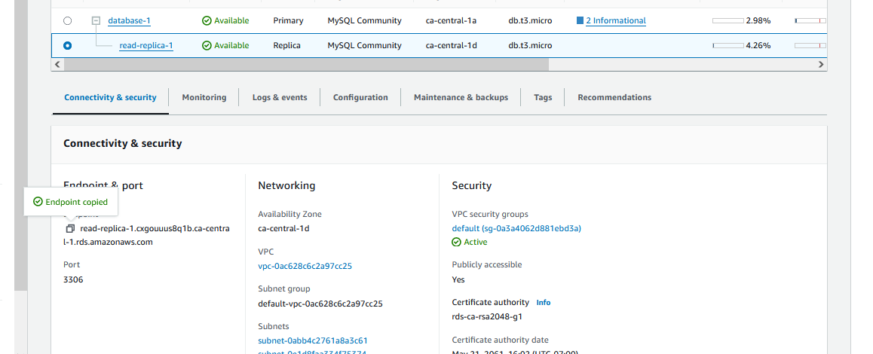

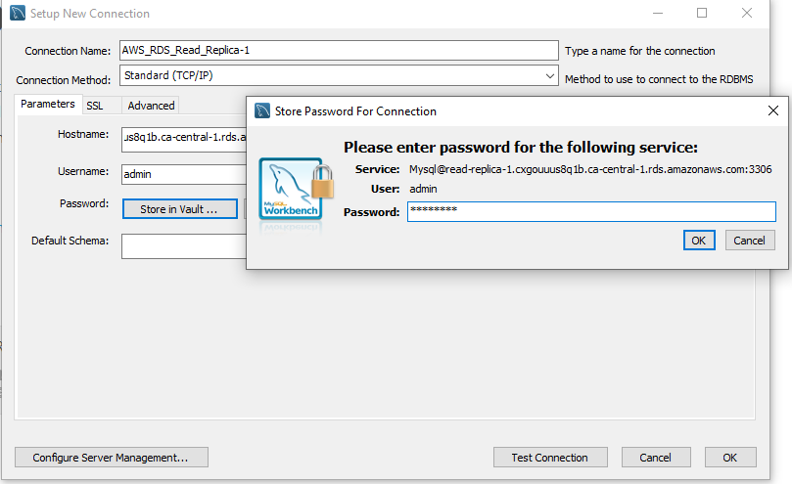

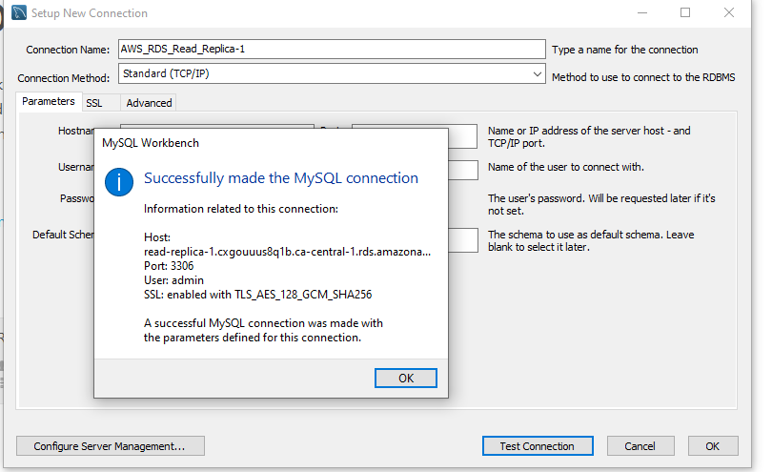

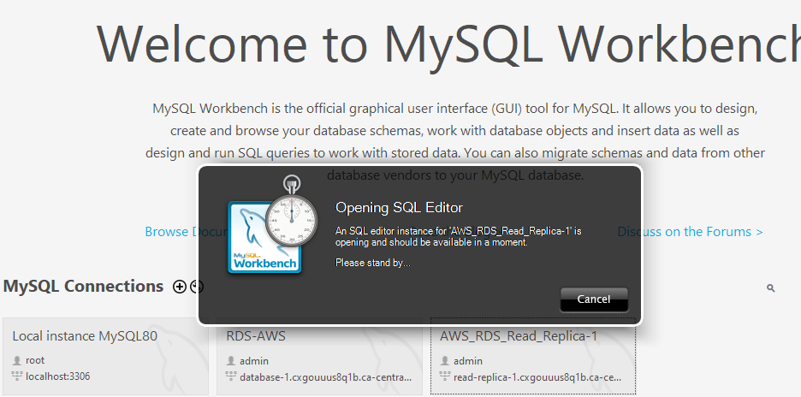

All table info available in read-replica-1 without creating any data.

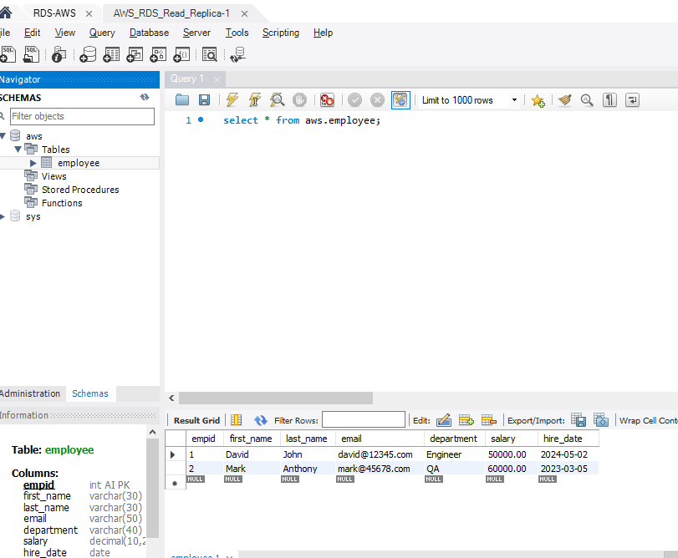

Create 3rd record in Master db

|  |
| --- |
| insert into aws.employee (first_name, last_name, email, department, salary, hire_date)  values ('Honey', 'Mony','honey@88765.com','QA',66000.00,'2022-08-22'); |

Now try to create 4th record in read-replica-1, lets see..

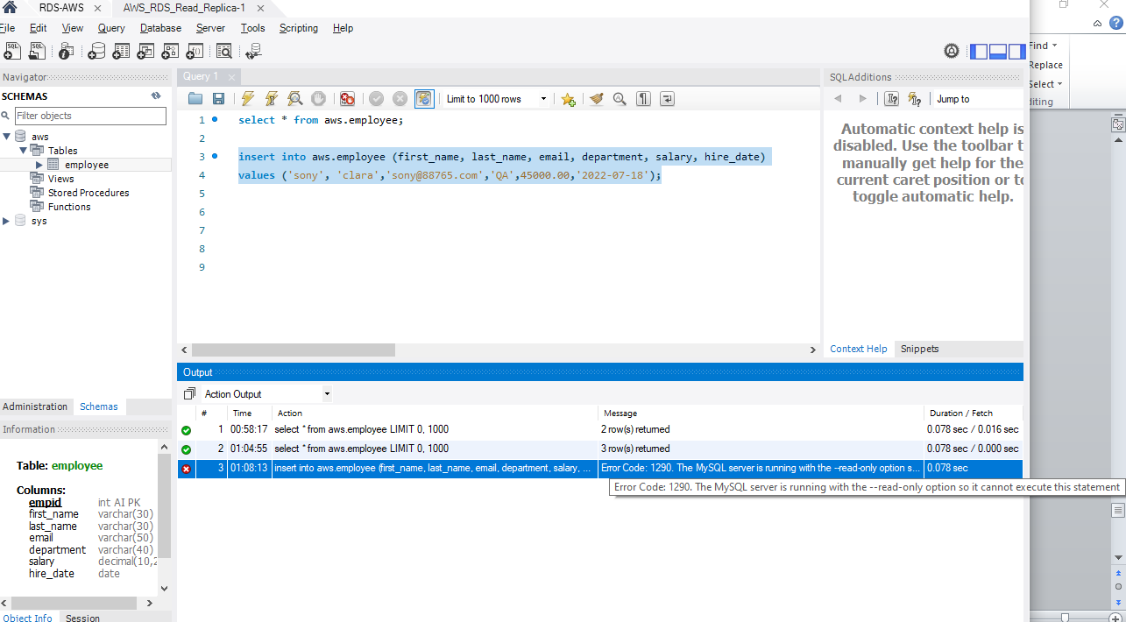

Error:

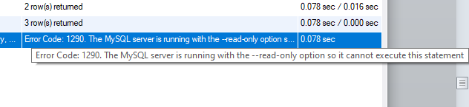

By seeing this error we have no access to execute insert, delete queries in read-replica-1

Try to delete a row from read-replica-1, lets see

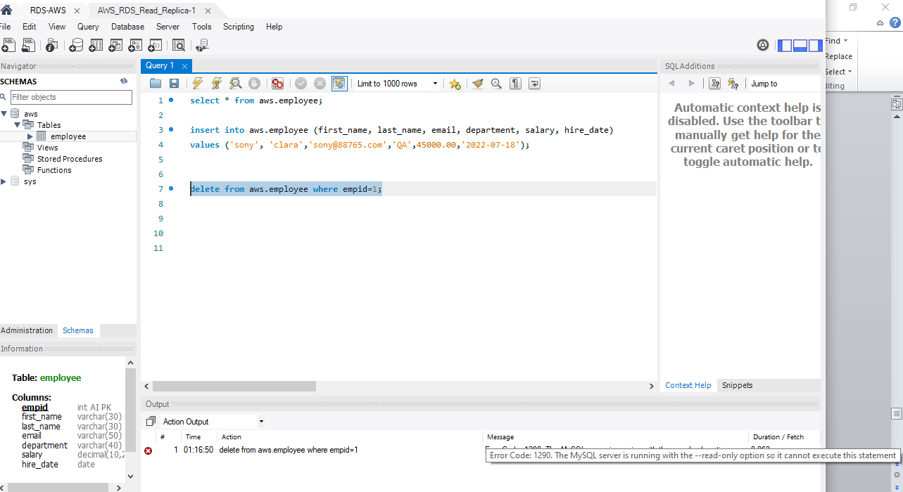

Delete query also not having the permission in read-replica-1 db.



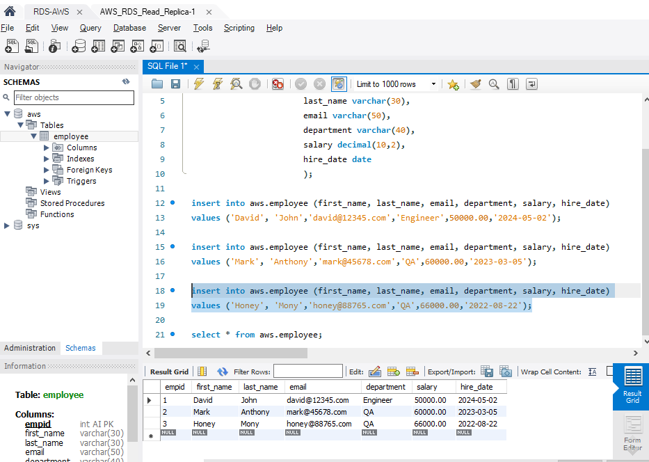

The master data immediately reflecting into read-replica-1 db

